**ROLL NO: 20SW042**

**LAB: 6 SQL**

**SECTION: 2**

**Task 1A**

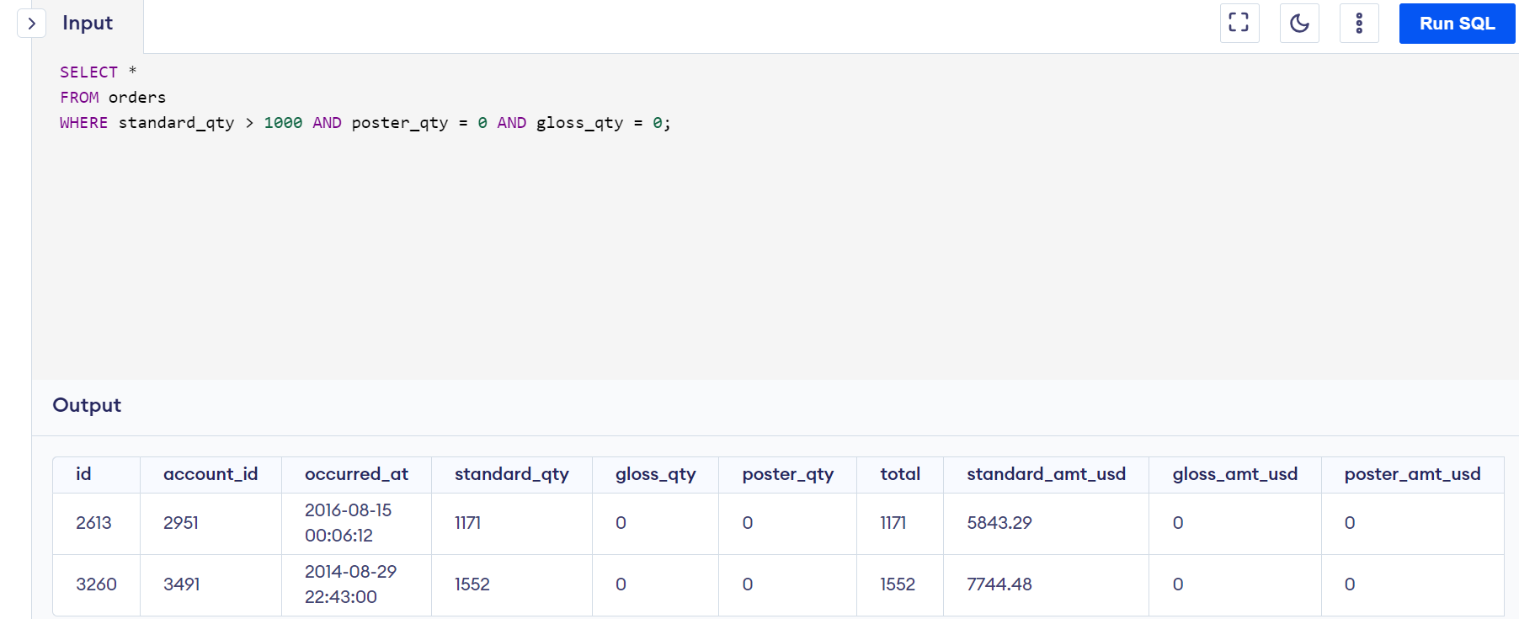

**Task 1B**

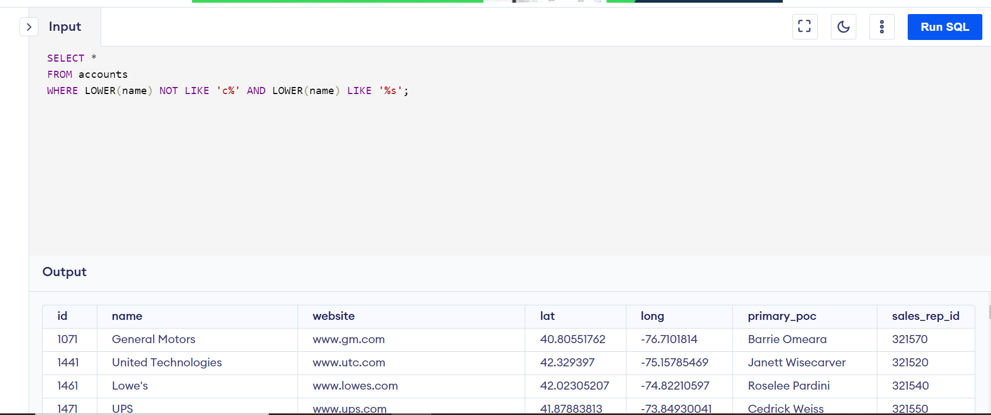

**Task 1C**

**Task 2A**

**Task 2B**

**Task 2C**

**Task 3A**

**Task 3B**

**Task 3C**

**Task 4**

**Task 5**

